

Mentoring, Training & Placements Department
Daily Report 16-03-2026
Description |  | Total to be received | Received till Date | Received Date | To be received

II | Staff Attendance
S.No | Dept. | Category | On Rolls | Absent | DQI | DQI Performance | Overall DQI | Overall Performance
1 | MTP |  | 8 | 0

 | III. Students’ Attendance:
IV | MTP:  SAMUEL  - Quest Global - scheduled virtual interviews for 6 students (ME & EEE) today. Coordinating with students.  - Amazon Internship hiring for 2027 batch - 8 students have virtual interviews tomorrow. Dr. Achuta Ramaiah has taken a session in-person and oriented them. Coordinating with students to ensure their participation as per time slots.  - Ambianz campus drive - 22 students from Mech & CE attended the process. Mr. Thomas, Mr. Mathews addressed the students. Aptitude Test, Group discussion are organized. Interviews are in progress  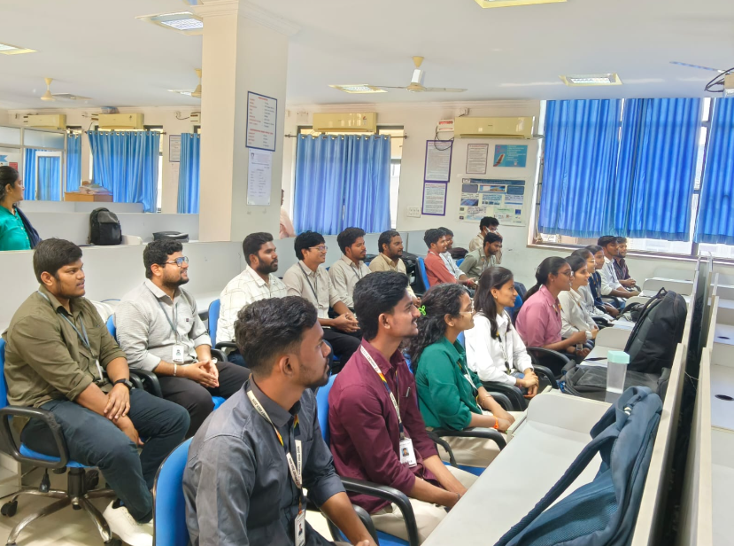 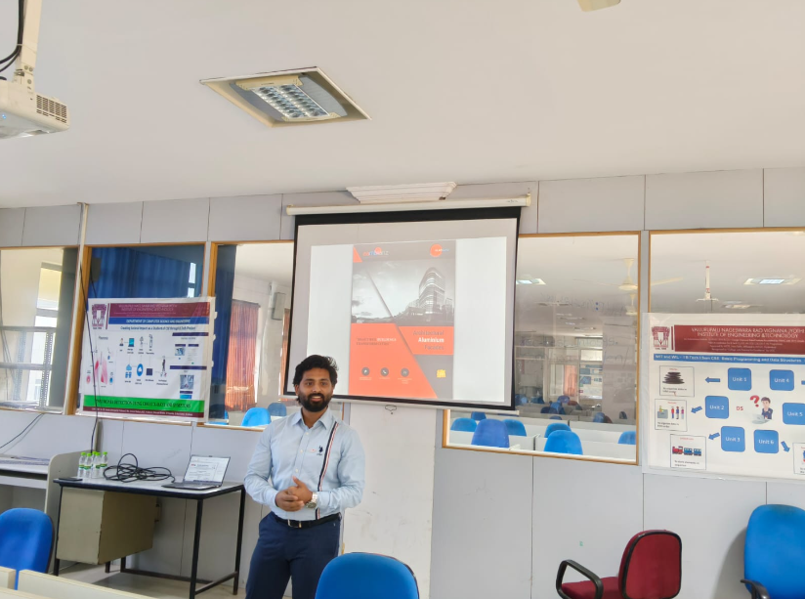  KABITA  - ISSQUARED: Konda Sathvik- 22071A6726 from CSE selected for GET with 5 LPA.  - FedEx: 3 students selected for FedEx Initial internship 3-6 month with stipend: 35 K upon FTE package will be 10 LPA. Information shared with students.  - Choice Solutions: 3 students selected for GET with package 4 LPA.  - Carzzi: 23075A2404 Banala Lokesh Reddy from AME selected, job Role: GET with package: 4 LPA students joining scheduled from June-26.  - Ctrls: Technical interviews completed on 13th March for 13 test shortlisted students. HR interview scheduled today at 11:30 AM. Result awaiting.  - DTCC: for batch 2027 on campus drive scheduled on 17th.  POONAM  - KPI-TECH Services- hiring - paper-based assessment was conducted for 15 shortlists which was scheduled today on16th March 2026 from 12:00 PM to 2:00 PM.  - Dr K V M Achuta Ramaiah conducted a training and orientation session today from 2 PM to 4 PM for the 3rd year (2027 batch) ME, CE and AME shortlisted students for Amazon Internship virtual interviews scheduled for tomorrow, 17th March 2026. 7 students attended the training session.  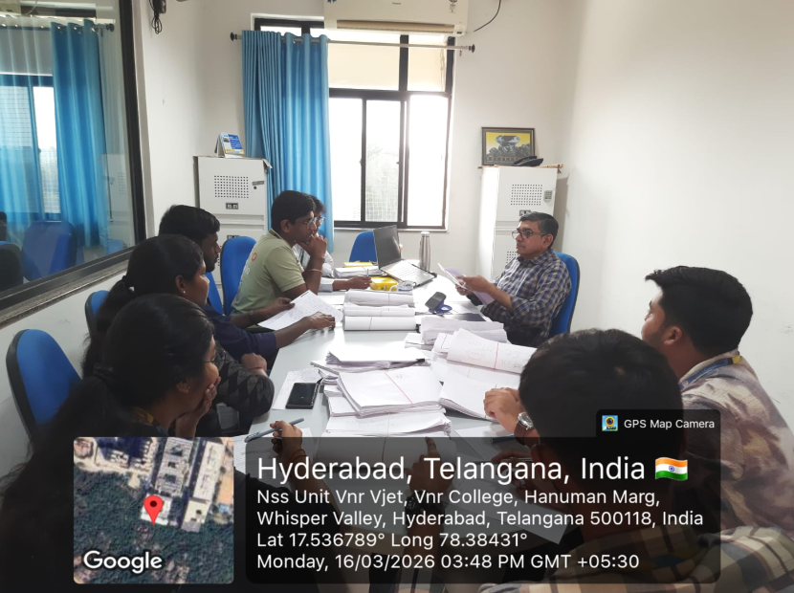 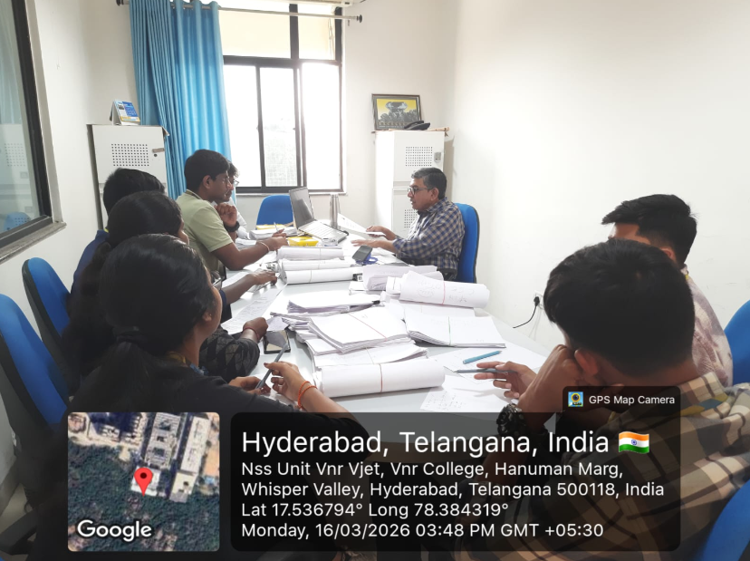  V HOD-CSE (CSDS&AIDS):  VI HOD-IT:  VII HOD-ECE:  2025 2026 Batch Plis open Summary:  CSE CSBS AIML IOT DS CyS AIDS IT ECE EEE EIE ME CE AE M.TECH TOTAL  354 64 276 83 182 62 63 244 205 76 91 50 49 17 12 1828  2025
VIII Classwork Adjustment / Lectures Interchanged:
S. No. | Dept | Subject | Adjusted from | Adjusted to

IX. Participation by Staff/Students:
S.No | Name | Event | Status (delegate /paper)resent, speaker) | Date and  Duration

X | Particulars of Library Services or Transactions: | No.s

For Head of the Department.

